10. Tuning of autoISF settings for Full Closed Loop aided by the emulator V.3.8

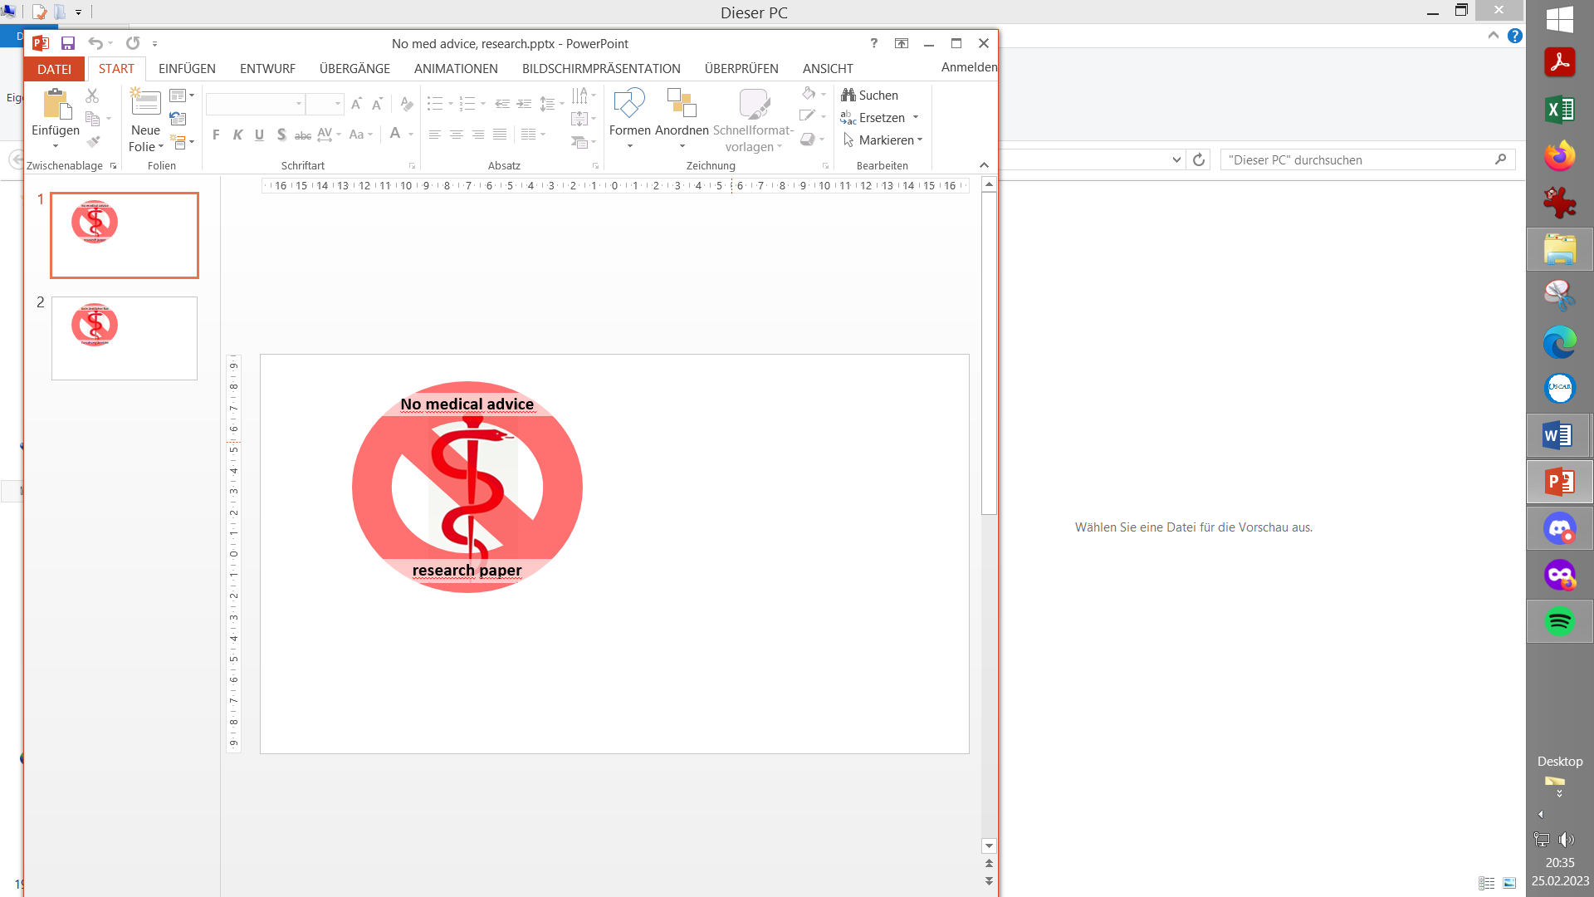

**Please note that with autoISF you are in an early-dev. environment**, where the user interface is **not optimized for safety** of users who stray away from intended ways to use.Good safety features exist, but these are only as good as the development-oriented user understands and implements them. This is not a medical product, refer to disclaimer in section 0

Available related case studies:

Case studies still missing:

Based on older autoISF and older emulator versions, examples from emulator use can be found in case study 6.2,in case study 4.1 (last pages there)*,* andcase study 8.2

10.1 Installing the Emulator on your PC

10.1.1 File structure on your PC

10.1.2 Load config and py files

10.1.3 Desktop button “Emulation_start”

10.1.4 Other software requirements

**10.2** Analyzing **loop decisions** in logfiles

10.2.1 **noChange**.vdf

10.2.2/3 Locate logfiles / prepare Emulator

10.2.4 Run emulation and inspect results

10.2.4.1 .txt (all SMB tab infos)

10.2.4.2 Tabular (.csv) presentation of all loop decisions

10.2.4.3 Manual extraction of key data into .xls or .odc

10.2.4. 4 .pdf chart

10.2.4.5 delta table

**10.3** **What-if** analysis

10.3.1 Define (**yourChange**).vdf

10.3.2 Run emulation

10.3.3 Inspect results

10.3.3.1 Logs (all SMB tab infos)

10.3.3.2 Tabular (.csv) presentation of all loop decisions

10.3.3.3 Semi-automated extraction of key data

10.3.3.4 .pdf chart

10.3.3,5 delta table

You can set up and tune the system for Full Closed Loop as described in previous sections. Doing this by frequently analyzing screenshots that must be taken in real-time of the AAPS **SMB tab** is tedious, however.

More elegant and precise tuning can be done with a special evaluation software for the AAPS logfiles, by using the **emulator.** It is described here: <https://github.com/ga-zelle/APS-what-if> / Documentation-in-English. There (under / Software) you find the files needed to download on your PC, and the primary instructions:

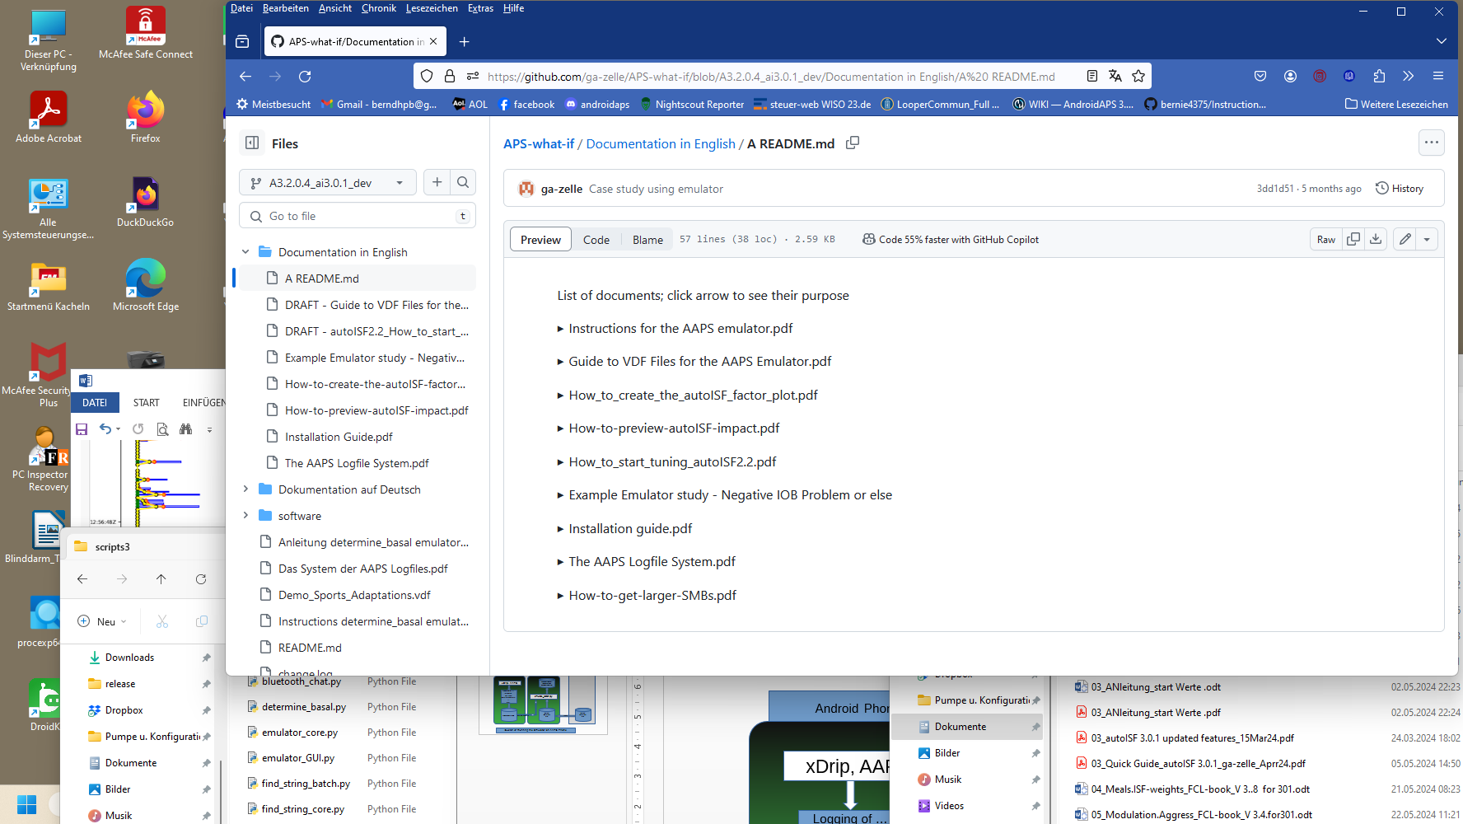

Note: Look it up in the most up-to-date branch

In the emulator, you can see in tabular and graphical form, which autoISF component, and other settings, contributed to SMB values that determined the glucose curve.

In the following, we look into how you create your relevant data. Application examples for tuning are given in associated case studies (we need newer ones).

Note that the iOS based variants of autoISF for Trio or iAPS (oref loops for i-Phone) can not use the emulator. Refer to section 11.3.

Join <https://discord.gg/n3tD5eXExC> for seeking (and giving) help with the emulator set-up or use, and to exchange experience.

10.1 Installation of the emulator on your PC

Installation is a one-time process, and you best refer to the installation guide of the developer, here: <https://github.com/ga-zelle/APS-what-if/blob/A3.2.0.4_ai3.0.1/Documentation%20in%20English/Installation%20Guide.pdf>

Below, I attempt to spell out some additional details “for IT dummies” (like myself)

* + 1. Create your PC folder structure

The suggested folder names and structure shown below is of course not mandatory, but only a suggestion.

On your PC, create a folder “**Logfiles_Emulator**” with 3 sub-folders: “AAPS _logs”, “Emulator” and “Emulator_Studies”

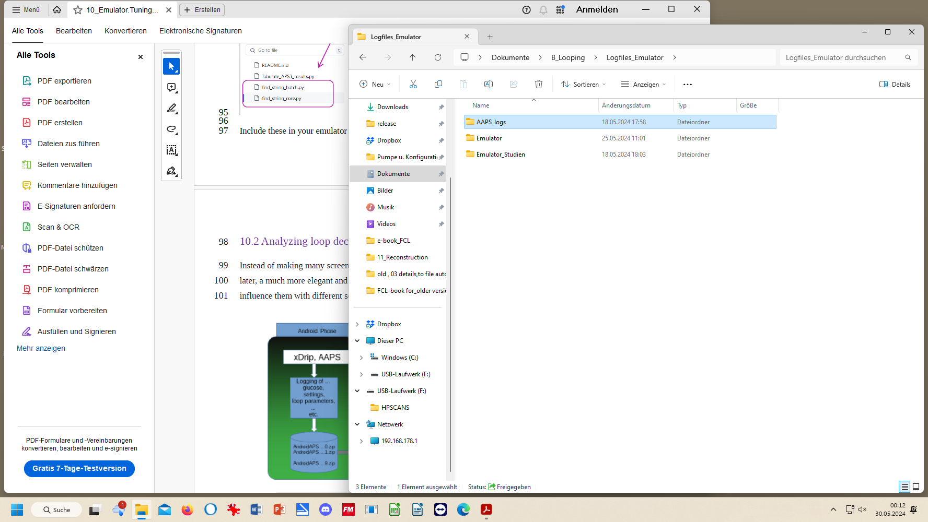

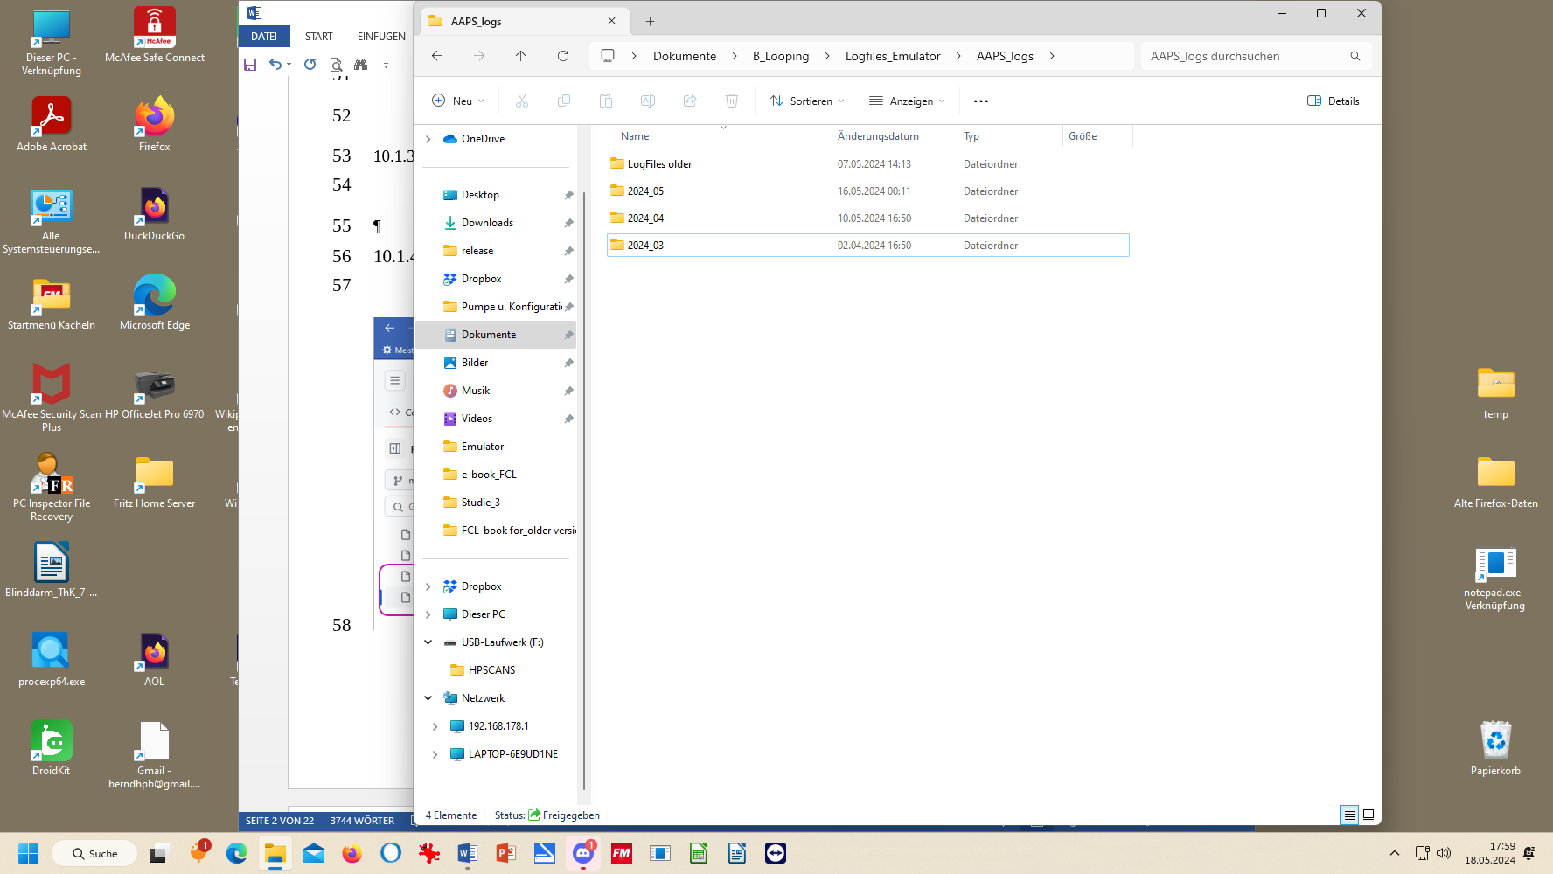

**AAPS_logs:** Put all your stored AAPS logfiles into that sub-folder. My folder structure for Logfiles and Emulation on the PC has 3 monthly folders, plus one folder with data from previous months and years (which I am less likely to analyze).

The logfiles you ALWAYS must copy-in from your phone before they get automatically erased there after x days (about 2 weeks, much shorter for 1-minute Libre3).

It is advisable to additionally store a pdf from **Nightscout Reporter** in the file for every month, with daily glucose charts, 24h scatter graph, etc. From it, you can much easier find which days and times are of high interest to analyze with the emulator.

.

**Emulator:** Neighboring “AAPS_logs” is the “Emulator” folder into which most downloads from the developer’s repo will go in section 10.1.2

**Emulator_studies** is a folder, where, for now, you should provide some **sub-folders** “Study_1”, “Study_2” … **Study_n**. Later, when you use the emulator, you will use these “addresses” for the program to dump results from the emulation into. Additionally you will probably put related AAPS screenshots and Nightscout.Reporter or xDrip/Statistics charts into each project folder to support analysis.

10.1.2 Downloads

1).Download from: [https://github.com/ga-zelle/APS-what-if/  **software**](https://github.com/ga-zelle/APS-what-if/%20%20software), the .**config** and four **py**. files. To do this, you must (5 times, one at a time): click on the name here, and, for download, here

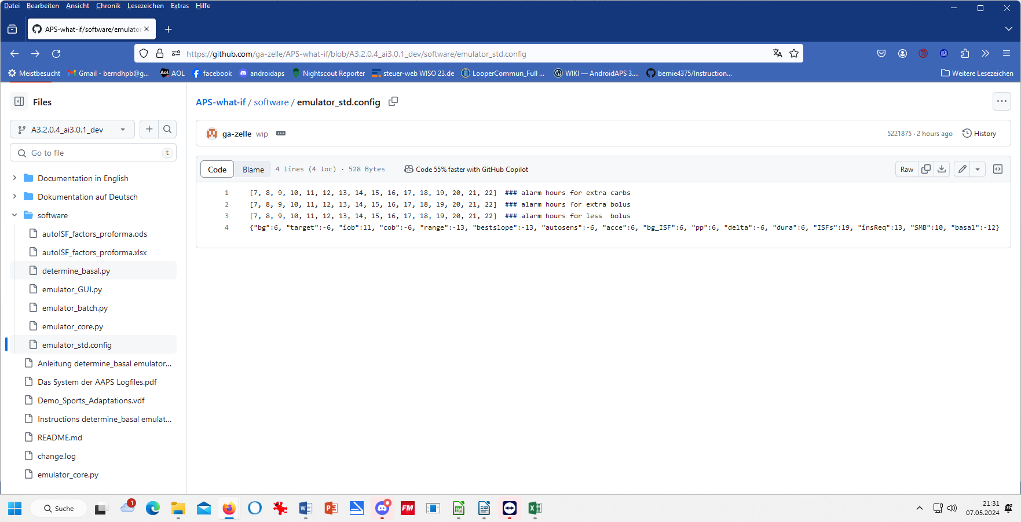

Always see to it that you are in the correct branch

Always make sure you use the files from the branch with the same version number as your AAPS version (in the example above: These files will work with AAPS dev version 3.2.0.4 with autoISF version 3.0.1). . Always keep your AAPS x autoISF and also the emulator related files up-to-date. If you can’t get your Emulator run, look in the Github repo whether there is a newer .py file (even with the same name; there may be updates that iron out problems that may have been reported only with certain AndroidOS versions etc etc))!!

2).Retrieve these 5 downloaded files on your **PC (list of recent downloads)**, then:

3). Shift each of these 5 into your “Emulator” folder:

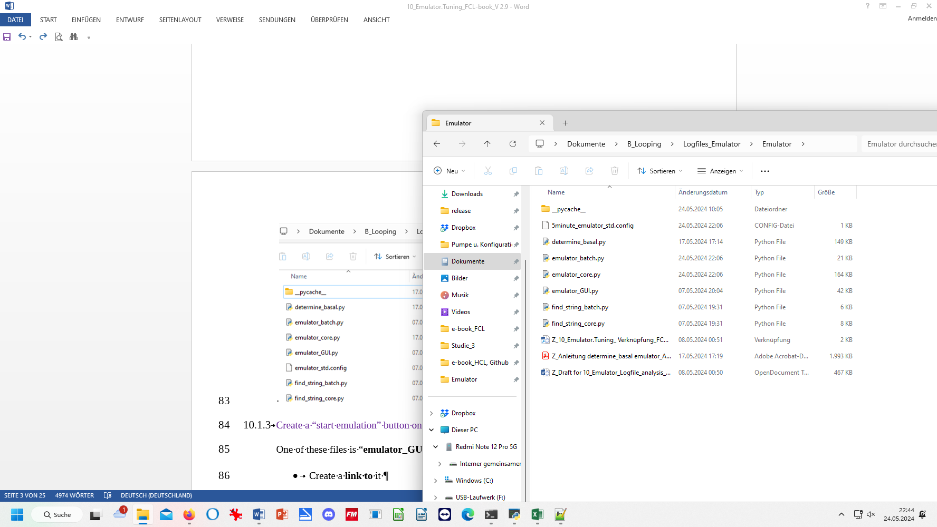 Note: Use 1minute:emulator_std.config in case you use Libre3 (1 min) as your CGM

see 10.1.2 .4)

4).From another section in Github, “Scan-APS-logfiles”, fetch two more .py files by

repeat steps 1)-3). for these two. They are from: <https://github.com/ga-zelle/Scan-APS-logfiles/blob/main>

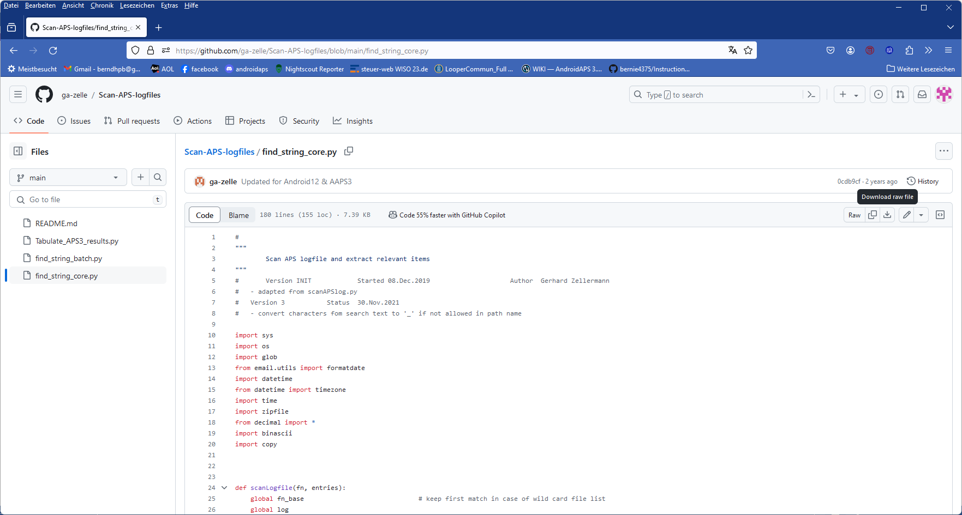

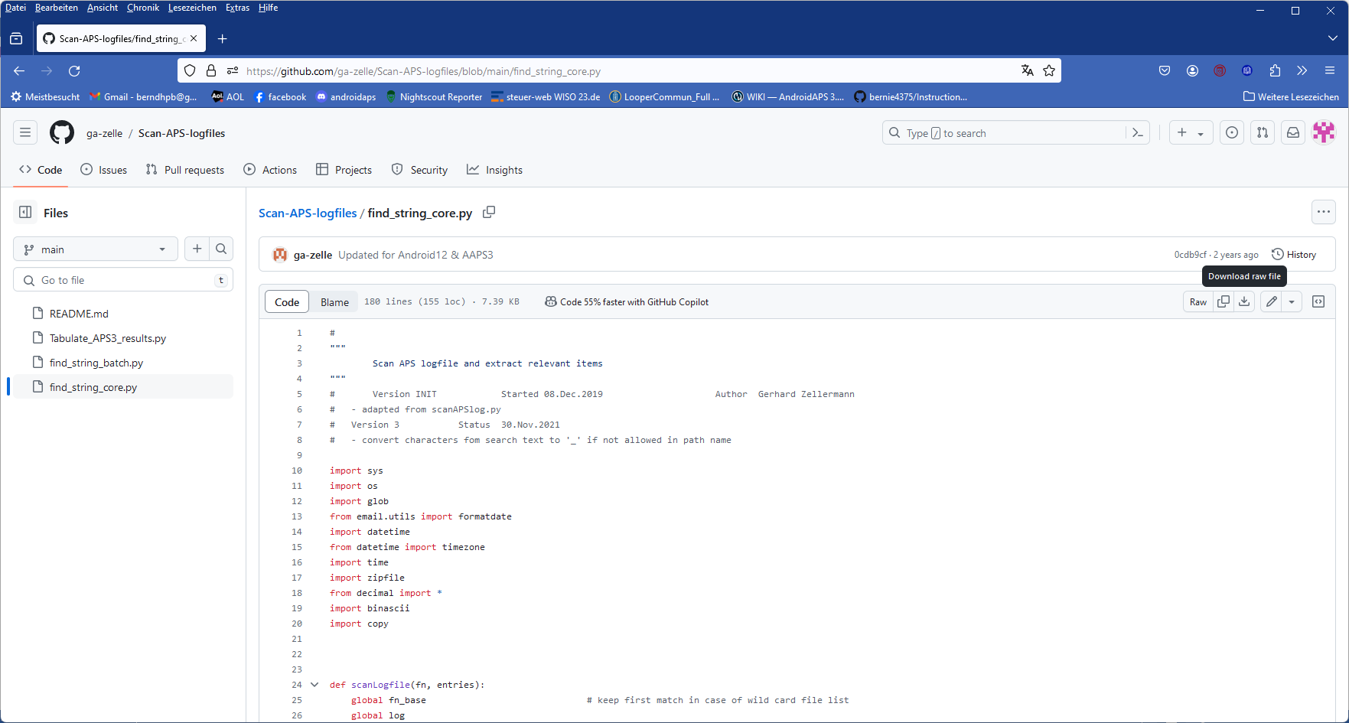

5)-Retrieve these two .py files in your PC’s downloads folder, and move them into your emulator file (as already was included two pictures higher up).

* + 1. Create an “emulation start button” on your desktop

One of the files in your “Emulator” folder is “**emulator_GUI.py**“

* Create, in your Emulator folder, a **link to** it
* Drag **that link** onto your **desktop**
* Name it something like “Emulator_start”: This is your **start button** for emulations on the PC
  + 1. Other software requirements

Make sure you have **Notepad++** on your PC (see section 10.2.1).

QPython 3L will be needed on the smartphone, later (see section 11).

* 1. Analyzing loop decisions in logfiles

Instead of making many screenshots every 5 (or, w/ Libre3, every 1) minutes after meals, and analyzing them later, a much more elegant and powerful way to analyze your loop decisions (and how you might want to influence them with different settings, see section 10.3 for this), is to use the emulator.

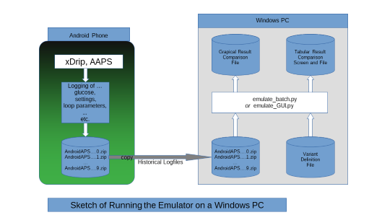

Github/ga-zelle / APS-what-if

10.2.1 Set up a “no change” .vdf file.

1).To do this, just open **Notepad++** (from list of all programs on your PC).

2). Name your file “noChange.vdf”.

It is just empty in the lines that would define any change to be investigated.

Note: for “what-if” analysis, entries will be made (in a second .vdf later, see section 10.3 )

The no change .vdf should look like something like this:

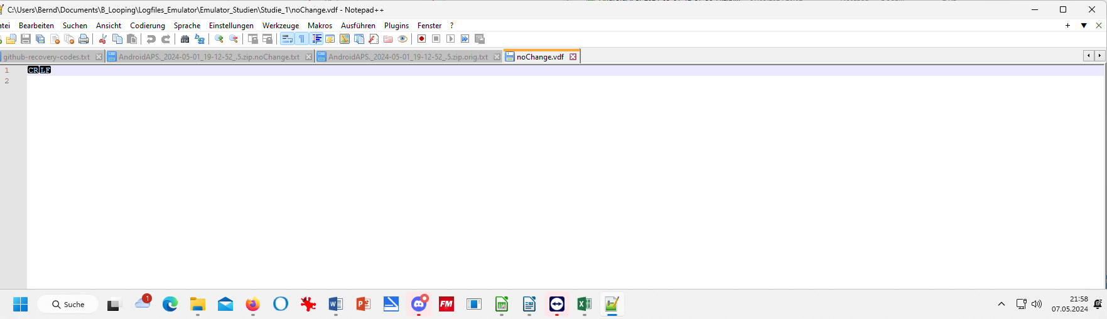

Lines 1 and following should all be free (CR LF might show, depending on your settings in your WORD program)

3).Store that “noChange.vdf” in your “Emulator studies” folder, on the top level, besides the single studies folders

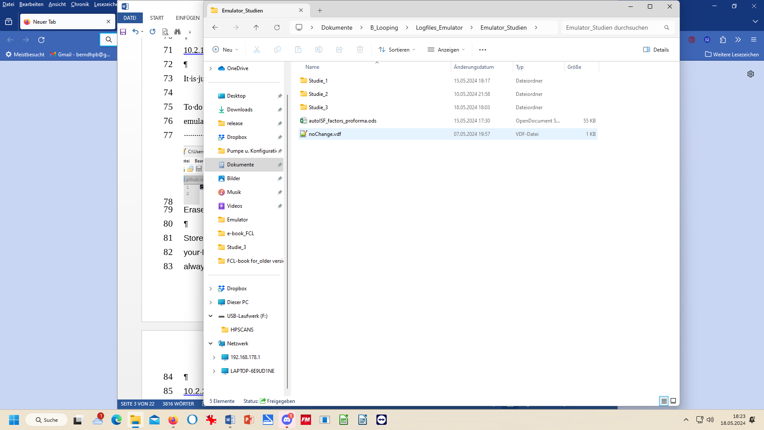

4).From that position, you always make a copy, and paste *into each* Study*_1 …n :*

See section 10.3.3.3. regarding this ->

3x copy / paste

10.2.2 Locate relevant logfiles and prepare the Study_n folder

1). Make sure you have the AAPS logfiles that you want to analyze in your “AAPS_logs folder”

2). In your “Emulator_Studies” folder, create (or use a prepared) “Study_n” sub-folder, with a copied-in (not: moved!) noChange.vdf (It must be *in all* Study_n files).

10.2.3 Prepare your emulator run for Study_n

Now go to your PC **desktop**, and start the emulator by **just pressing the button “emulator start”** that you installed in step 10.1.3

This opens a big dialogue box with 3 fields that you must fill in with the applicable path (*without* any

quotation marks “..”) from your Windows Explorer file system, best done via (3x) Browse button:

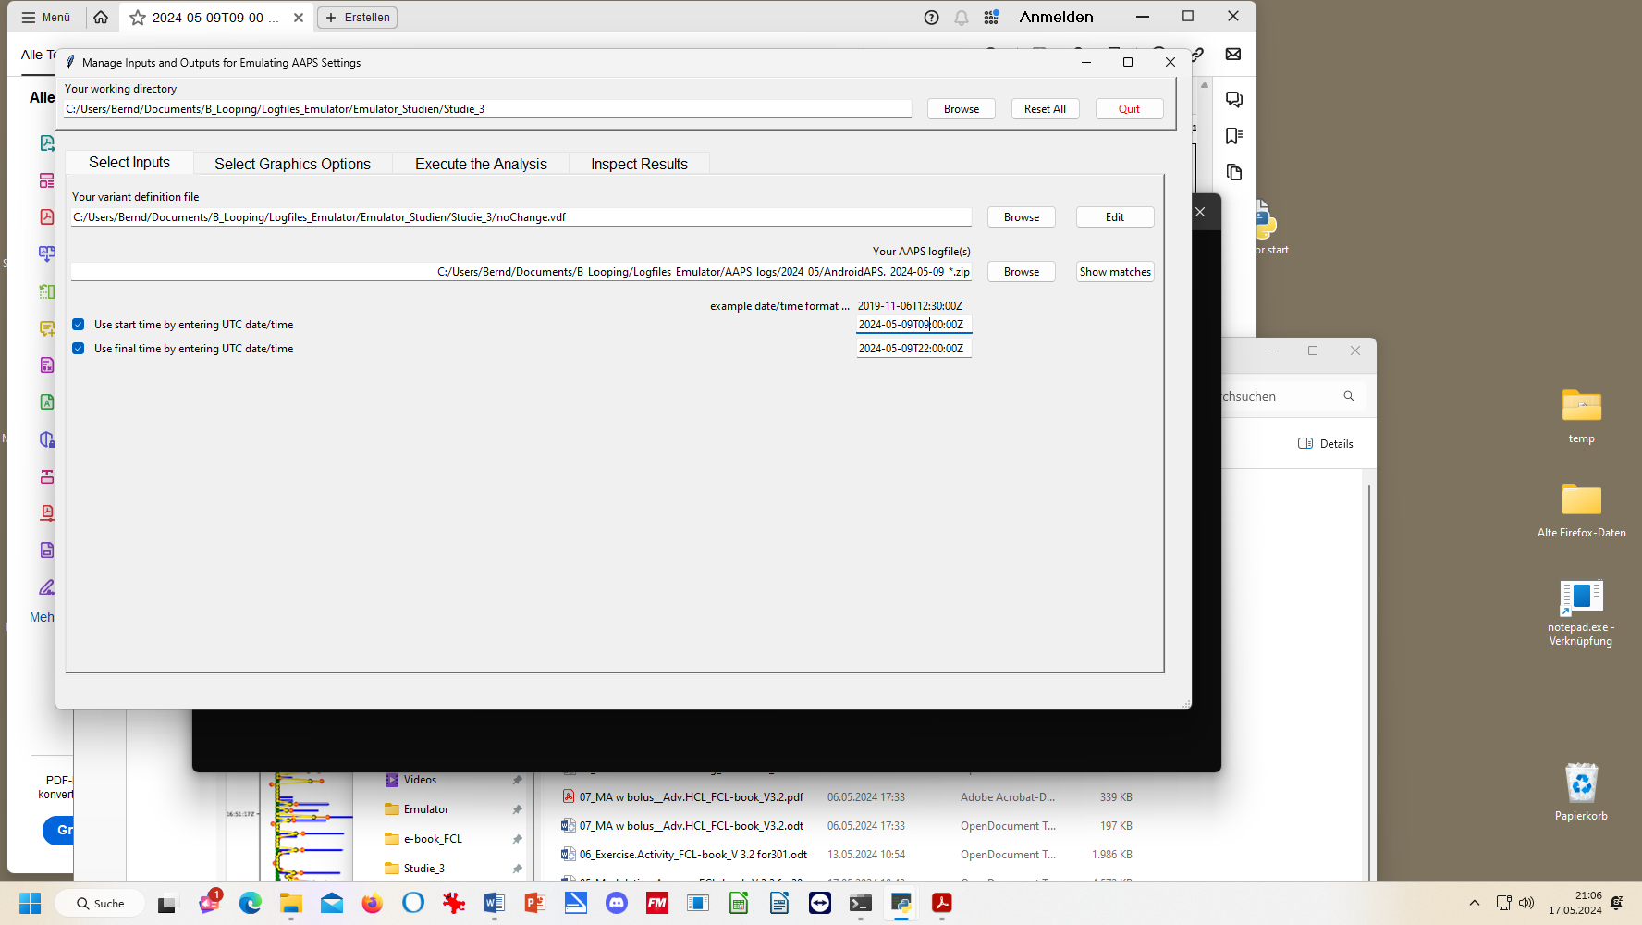

1. The top box marks the path to your current emulator project (“Studie_3” is my “Study_n” where I want to store results)
2. The middle box marks the path to your current vdf (what kind of analysis; here: “…noChange.vdf” *= read-only*. (For *what-if,* see section 10.3)
3. The third box marks the path to your AAPS logfiles you wish to look into. A good way to do this is:

* Browse in your Windows Explorer to any logfile from the desired day (2024-05-09 in above example)
* Replace the time with an asterix * (this means you look at **all-day** data, in UTZ time). Check whether this will work by pressing Show matches . You should see all logfiles from that day in a pop-up info box.
* As I wanted to look at 11 am –midnight (for lunch and dinner related data), I :
  + clicked the bottom left two boxes
  + copied the date 2024-05-09 over the default date in the bottom right two data fields
  + after T (for time), I entered the desired time of analysis AFTER conversion into my local time (Central EU summer time minus 2 hours = UTZ; so to look at 11 to midnight of my AAPS screen, I must enter here 09.00:00Z, and below it 22:00:00Z).

Entries at the bottom are not mandatory, but when clicking these little boxes (bottom left) you can define a start and/or an end-point for analyzing, within the logfiles specified in the field above.

10.2.4 Run emulation

Now we are ready to go: Press “Run emulation”

This produces sometimes an error message (e.g. if you have a syntax error, or incompatible software versions: => seek help, in the Github materials provided by ga-zelle, or in Discord/Full-Closed-Looping/emulate-aaps here: <https://discord.gg/n3tD5eXExC>

After a short moment results should show up, which you can look into in a couple of ways.

Optional: You could have a quick look into the **.log** file to see whether the run had errors (see section 3.8)

* + - 1. SMB tab contents in (date..) **noChange.txt** result file

This …txt file basically gives you “all the SMB tab” infos, in a super long list (but without needing to make screenshots in real-time, every 5 minutes.)

Search options help find what lines are of interest to your analysis:

By using the **search function** you can jump, in that super long list, to all places that e.g. have „autoISF“ in it or „script debug“, or „SMB disabled“ (if you want to analyze when that happened). Precise spelling, as in this .txt (or in SMB tab) is of course important.

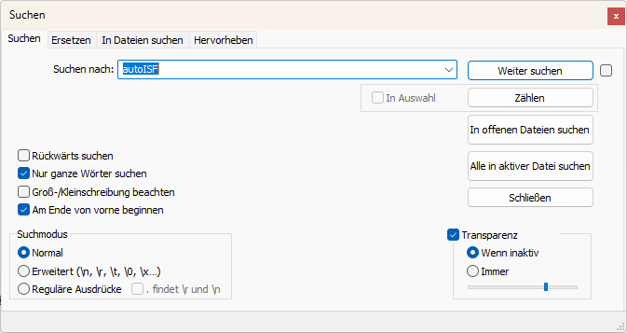

search term

press to go to next place w/ it

10.2.4.2 Table of results (…**noChange.csv** file)

The .csv file in your project folder gives a tabular presentation of how parameters like bg, iob, iobTH, the various ISF contributors, bg target, insulinRequired etc. develop every 5 minutes, and what SMB size and %TBR resulted.

It is a vast table, so you may want to reduce it to something more “digestible”, either after transfer to your standard calculation program (next section 10.2.4.3). Or you can also make settings to suppress information you are usually not interested in (or do not know how to interpret, anyways) under “Select Graphics Options” when you open the emulator, before executing any analysis:

First, select your preferred way of outputting decimals (point or comma).

Then select whether you want “All” possible outputs in the graph, or “Most” = all except those you tick “off” in the boxes for each output parameter.

In case you would use “Some/just a few”, you would have to tick those few you that do want to see, by ticking the corresponding boxes.

Recommendation is to look at (nearly) everything offered (as your default setting that you can leave untouched in most of your emulator runs):  
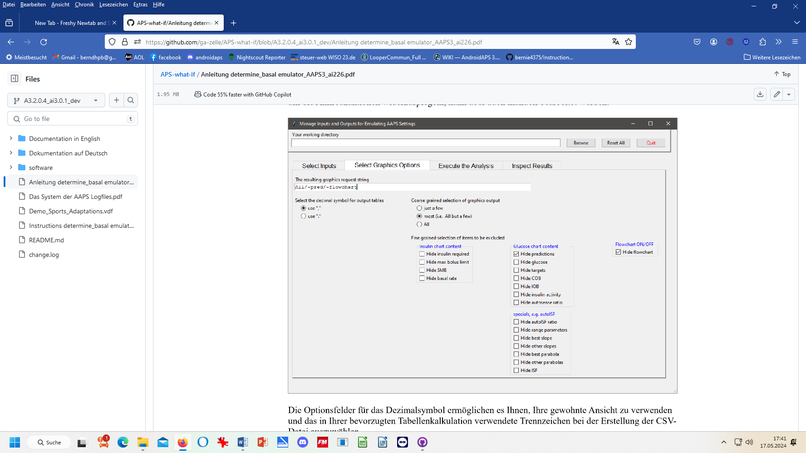

It might be easier, to not deal with customizing the csv file, and rather copy the data into your favorite calculation program:

10.2.4.3 Analysis of the **noChange.csv** table in Excel or LibreOffice calc.

Best copy the entire table into a new .xls or .ods sheet, where you can:

* add right next to the UTC (Unix Time Code) your corresponding “AAPS **time”**

For instance, adding +2/24 translates the UTC column into central European summer time column next to it (where currently a row of Z stands). Likewise, subtract like -5/24 from UTC for an US East Coast time scale. *(Fun fact: Our oref loop stubbornly works on UTC, un-impressed by our folly to jump twice a year into or out of a local summer time, or to travel across time zones. If some data get lost in translation there, it is only to us, with our stupid time change. For the loop, its database (e.g. on insulin activity) remains unambiguously intact).*

Highlight all time fields (both entire columns), and switch from hh:mm:ss format to hh:mm. *(While the seconds are important for the loop’s calculations, for our comparison with Nightscout or other charts and data, it is much easier without the seconds attached)*

* **hide** any column you find less important to look at for your intended analysis

That way, “boxes” (data fields) retain their original position in tables

Also, in case later you want to look into additional info, you can simply un-hide the relevant columns (or lines:.)

* **hide** lines (time segments) you find less important to look at for your intended analysis

Usually you will color mark where relevant SMBs were given, which of the ISFs (and underlying weights) was strongly contributing (note that this can be good or not good). Also where iobTH was exceeded, whether an Automation kicked in e.g. setting a TT, or when there were periods with zero insulinRequired.

In section 10.3.4 we present an extra tool that does a standardized table reduction and color marking for you!

You may be able to formulate a hypothesis or two, what settings (…ISF_weights, iobTH%, SMB_range_extention, autoISFmax …) should be changed for improvement (then go to 10.3)

10.2.4.4.. Graph **noChange.pdf**

After your emulation run, under Inspect Results, you can open the pdf file that is last in the results list offered.

This **noChange.pdf** is a chart that shows along the time axis (down), from right to left:

* Red: the bg curve
* Yellow: the bg target (note that I do no manual “EatingSoonTT” but for bg rises over +10 mg/dl I have an Automation that sets low TT for a couple of minutes)
* Light blue corridor: Left edge is set iobTH, and bandwidth +30% (would be +20% at elevated TT)
* Dark blue line: iob (exceeding twice the iobTH, with temp. SMB shut-off

As bg did not convincingly come down enough, one could hypothesize that iobTH should be elevated. ((But, again, this would have to be confirmed also with other kinds of meals)).

* Thin yellow line: Insulin activity
* Green dotted line: ISF as would result from AAPS w/Autosens
* Green scatter points: autoISF ISF no Chage (lighter points) or what-if (darker points)
* Black line: Profile ISF
* Gray scatter points: ISF weakened (to the left of black line) or strengthened (to the right)
* Orange line: cob=0 at all times (in FCL)

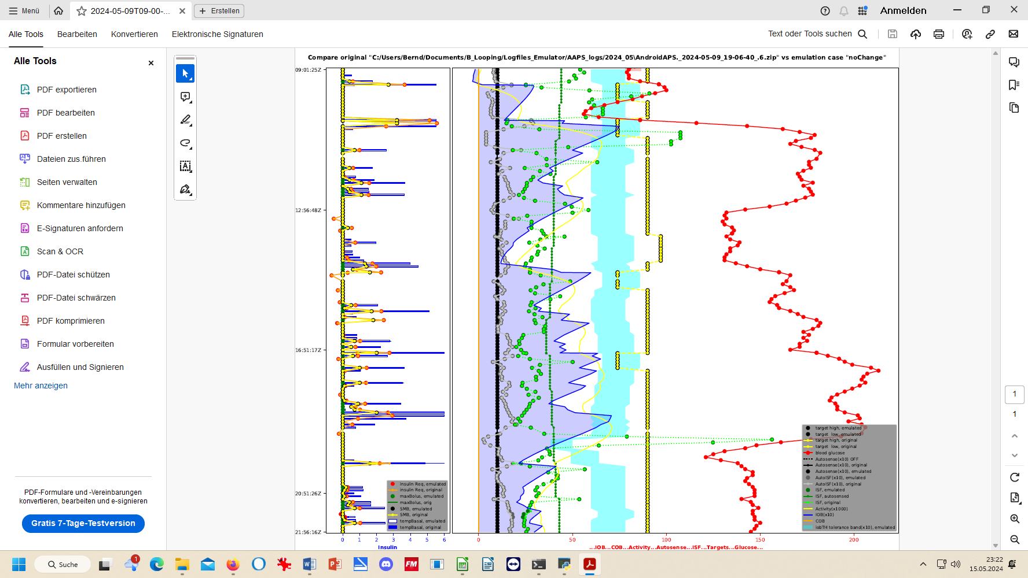

More see discussed together with (yourChanges).pdf in section 10.3.3.4

10.2.4.5 delta table

In case you want to analyze delta, short and long average deltas:

* you could do some of that just using your .xls extract from .csv (see section 10.2.4.3).
* There is also an extra sheet provided, “delta” (That works only if you have your **emulator_core.py** updated to the one from 02June2024 or newer).
* This is definitely core to FCL using Automations (section 13.1).
* When using acceleration detection via autoISF, the deltas are mainly meaningful to define personal Automations that involve Conditions using these glucose curve characteristics. An example would be to use the delta table to identify cases of compression low
  1. **“**What-if” analysis using the emulator

In the following you see an example how you can analyze a day of logfiles, and selecting the time span of interest, for instance 11-24 h to look at how autoISF managed lunch and dinner.

You will go through the emulator exactly as you already did in section 10.2. where you exclusively had the noChange.vdf on bord.

However, this time you focus on (yourChange).vdf, see below, 10.3.1..

Repeat, if you have two or more such vdf defined.

(Just clear old results before pressing “execute analysis” each time.)

**All results are automatically captured** for all runs, all **in your selected “Study_n”** **folder,** together with the noChange results

* Results files with noChange in their name are always your actual loop data …
* as opposed to results on “what-.if , that contain name of the (yourChange).vdf in their file name see e.g. at around line 380

**How to proceed, step by step**:

10.3.1 Define your investigated changes in (yourChange).vdf (one,. or several)

1).Define for which one (I suggest max three) parameter(s) in your current profile settings you want to look into a different setting. Recommendation is to use a factor, like for example: current setting * 0.9 , or current setting * 1.2, and use that in your naming for this vdf file, too.

You may want to consult [APS-what-if](https://github.com/ga-zelle/APS-what-if/tree/A3.2.0.4_ai3.0.1_dev) /[Documentation in English](https://github.com/ga-zelle/APS-what-if/tree/A3.2.0.4_ai3.0.1_dev/Documentation%20in%20English)/Guide to VDF Files for the AAPS Emulator.pdf Access directly, or via section 3.8

Within one study, you can make several emulator runs with several (yourChange).vdf files (all based on what really happened, as captured with the noChange.vdf).

All results, like the csv results table, will appear then *several times* in your study file, only *with different* *name endings* as in the underlying vdf.

Example: I like to check in my actual data (they are in my noChange.vdf emulator run**), in which time points the following parameter changes would make a** (how) big **difference** in the loop’s decision:

* 20% higher bgAccel_ISF_weight to boost the first SMBs stronger: How would that tend to ramp up early iob; and might that get too strong in other parts of the data? Or does it bounce into a restriction (maxSMB size; autoISFmax; iobTH…) that I might need to widen?
* Doubling my cautiously set bgBrake_ISF_weight shall give me insight into the workings of that parameter (and whether using a much smaller weight than for bgAccel_ISF_weight is really what I should keep doing)
* As my bg came down from a persistent high quite slowly, I elevate the dura_ISF by 20%

*Tuning advice:* Actually, it would make more sense to first find my “optimal”, maybe indeed elevated, bgAccel_ISF_weight. *Then*, in a *new* project_n+1, do (automatically) a noChange run **with that,** plus a (yourChange) run with the stronger dura weight, investigated *on that* basis. Reason: 1) As we always say, better do only one change at a time. 2) A better job with bg control via bgAccel_ISF will reduce the peak height and provide a different (easier) scenario for dura_ISF to manage.

2).Now, to **write** your **(yourChange). vdf for the emulator** (this is same procedure as you did in section 10.2.1 for the noChange.vdf):

* just open Notepad++ (from list of all programs on your PC) to create a new vdf:.

Alternatively you can also take another pre-existing vdf file, copy it into your current project , edit as desired, and give it a new name (re-name it)

**Caution:** Make absolutely sure (best by looking it up in the SMB tab, down in the profile set section) to **spell each term exactly** as your loop uses it (probably w/ decimal points, not comma)

* …when you make one line per parameter (separating entries with spacers->):

profile->(parameter) ->->profile[‘(parameter)’]*(factor)->->###(comment as you like)

The (yourChange) .vdf should look like something like this:

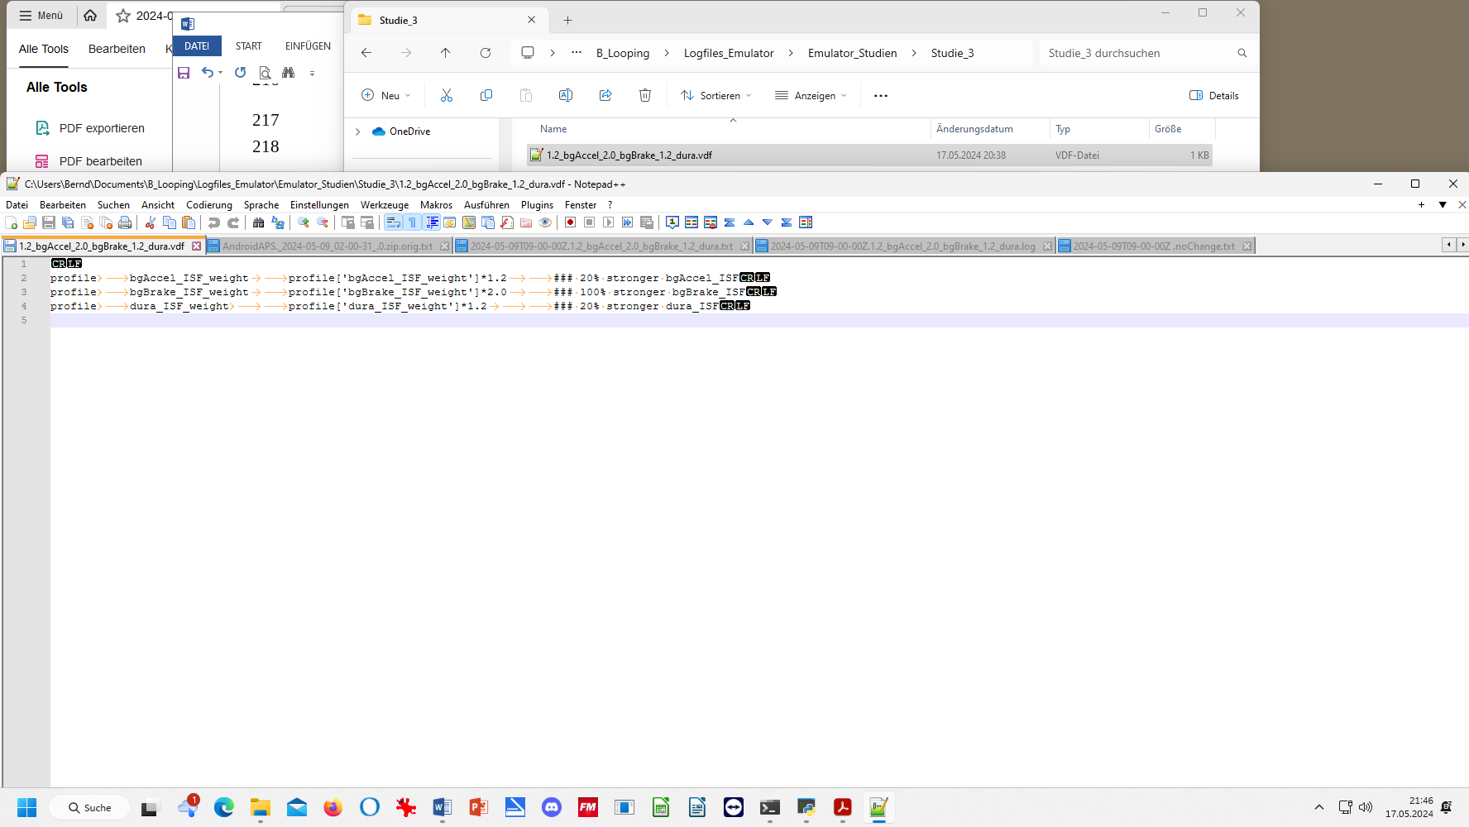

Via view/ show/hide symbols (CR , LF, tabs …), you can have different looks, see other example two pages down.

Or, with settings/view/remove symbols (for line feed, tab etc) it can also look like this:

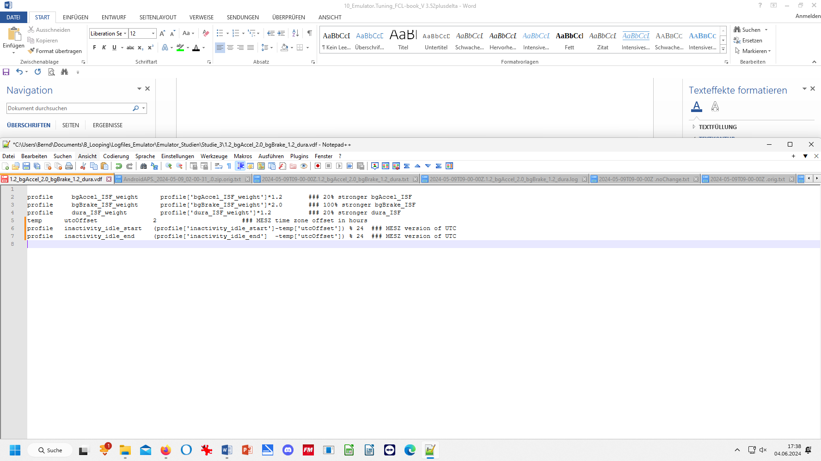

3). Name your vdf (in example below: 1.2_bgAccel_2.0_bgBrake_1.2_dura.vdf) …

4). Store this (yourChange).vdf in the folder for your current Study_n you are about to start (see my storage path C: ….. Studie3……….vdf – Notepad++ in the top line:)

10.3.2 Run the emulator with (yourChange).vdf

The “what-if” emulator run is done the same way as you did the noChange.vdf run (section 10.2), which had no (yourChange).vdf on bord

=> No surprise, running an emulation with only that noChange.vdf, yields same result in emul columns as is orig columns. - However, now :

The **(yourChange).vdf** must be loaded into the 2nd input field, where formerly you had the noChange.vdf.:

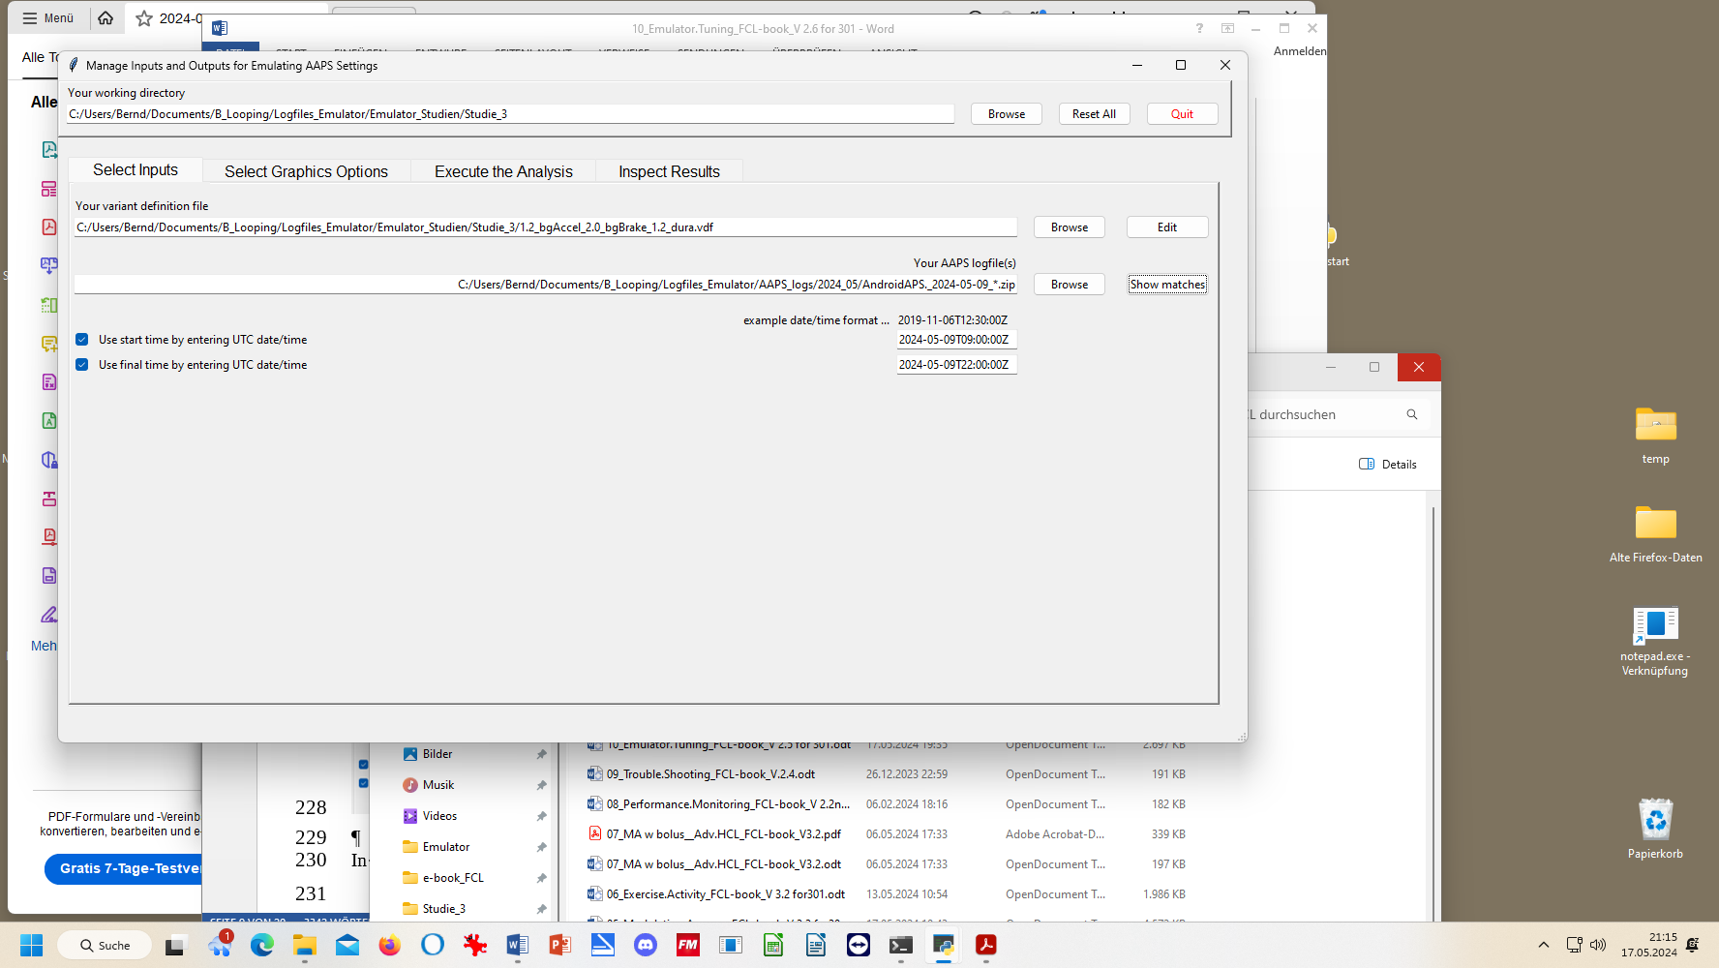

In the 3rd input field, give the path to your stored logfiles. A good way to do this is:

* Browse in your Windows Explorer to any logfile from the desired day (2024-05-09 in above example)
* Replace the time with an asterix * (this means you look at all-day data, in UTZ time). Check whether this will work by pressing Show matches . You should see all logfiles from that day in a pop-up info box.
* As I wanted to look at 11 am –midnight for lunch and dinner related data, I :
  + clicked the bottom left two boxes
  + copied the date 2024-05-09 over the default date in the bottom right two data fields
  + after T (for time), I entered the desired time of analysis AFTER conversion into my local time (Central EU summer time minus 2 hours = UTZ; so to look at 11 to midnight of my AAPS screen, I must enter here 09.00:00Z, and below it 22:00:00Z).

After making these entries, press Execute the Analysis, (evtl also Clear old Data) and then press Run Emulation, you can look the results up under “Inspect Results”. First you could have a quick look into the **.log** file to see whether the run had errors (see section 3.)

10.3.3 Emulation results

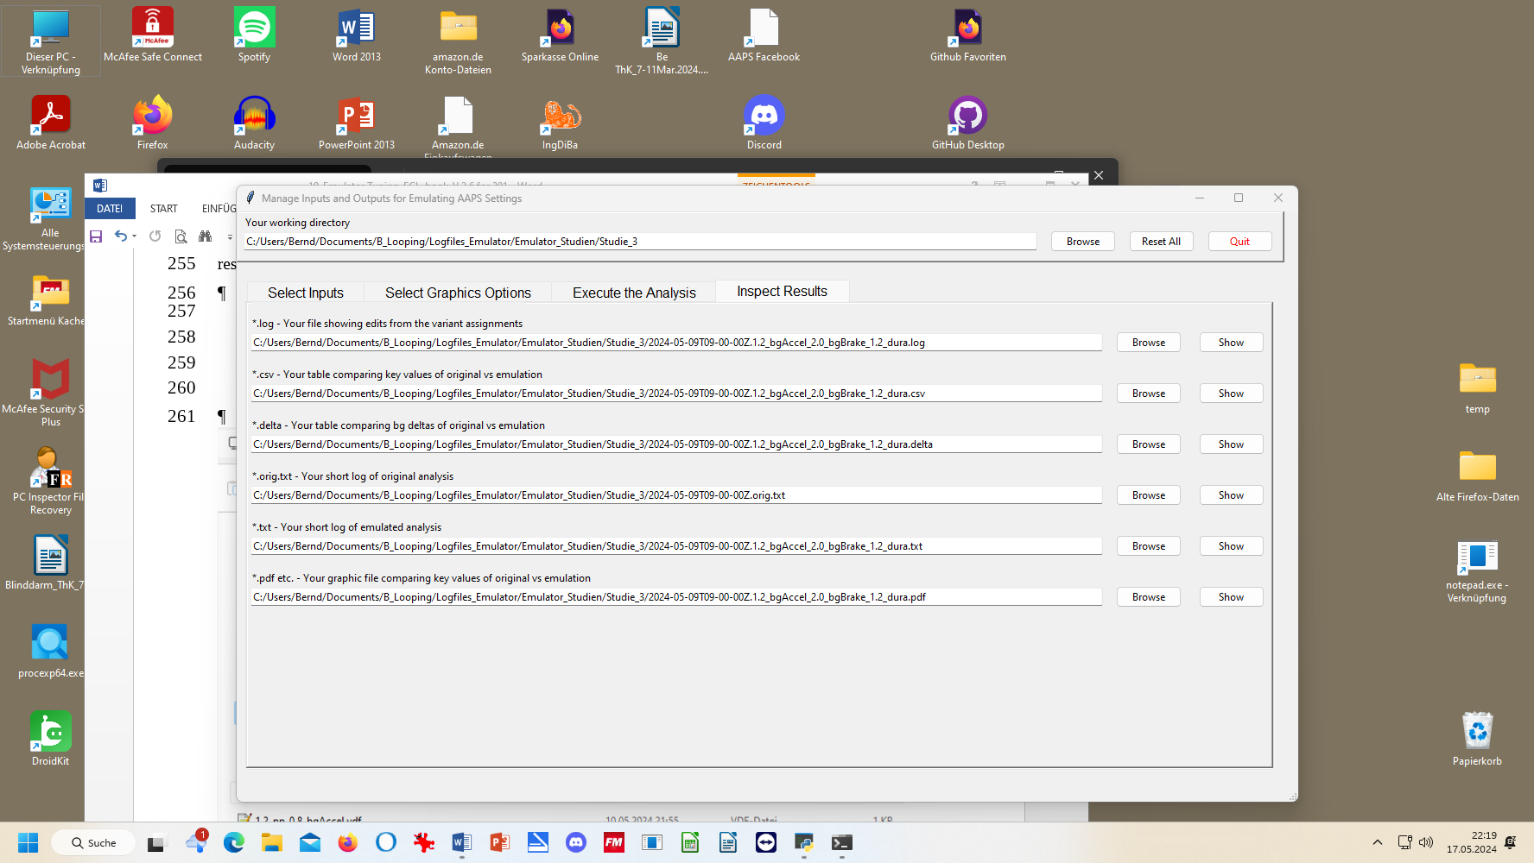

All results from your (yourChanges).vdf emulator go automatically where the noChange.vdf results are already stored, in our example into the “Studie 3” file, below:

Besides the 1.2_bgAccel_2.0_bgBrake_1.2_dura.vdf case which I like to look into for the present high carb meal, I also prepared another vdf that investigates a factor 1.2 stronger pp_ISF and a weaker, factor 0.8, bgAccel_ISF (with the intention to test this, and a noChange (that ideally would already contain the conclusion on adapting the bgAccel_ISF_weight*), on a low carb meal later.

*\* Note the challenge here is to iterate between the typical meals of your personal spectrum to find* ***one*** *set of settings that work good-enough* ***for all*** *of them.*

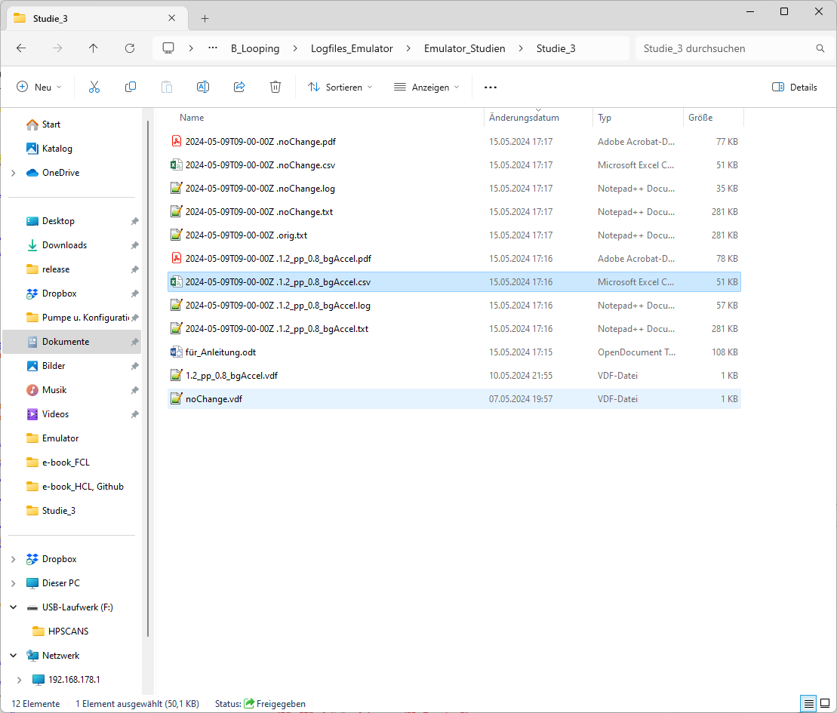

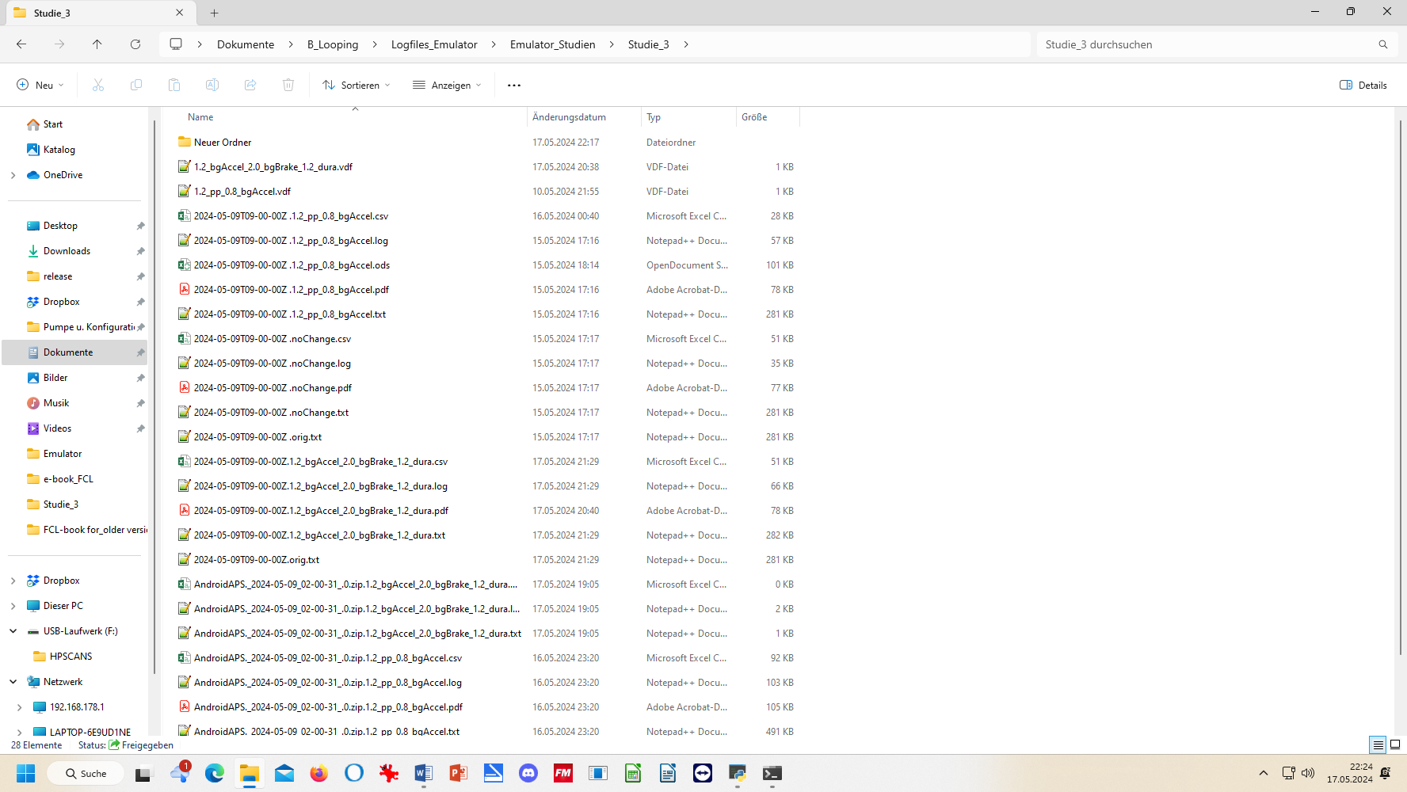





10.3.3.1….**(yourChange).txt**: “what-if” impact on loop decisions (as in SMB tab )

The **noChange.txt** has all the info your series of SMB tabs had that day.

How to search in this vast list is shown elsewhere (see section 10.2.4.3 ).

Likewise, the **(yourChange).txt** gives *for each loop decision* in all detail how and why each single decision *would have* changed with the different parameter inputs you are checking out here

In the two (yourChange) examples here, , it was a check on the difference

* a 20% stronger pp_weight and 20% weaker bgAccel_weight
* a 20% stronger weight for both, bgAccel_ and dura_ISF, and a doubling of bgBrake_weight

would make.

Note that all these “what if” data can only give rough hints, notably about **the first** greater change that you would see with the investigated changed setting. So it works quite well for our main problem in FCL, investigating how to ramp up iob quickly after detection of acceleration.

Note that any relevant change would put your bg curve on a different trajectory, so that would influence *all following* results. Therefore, what you get here is **not** a complete modelling how your bg would have developed in the alternative scenario.

But you can investigate in which stages the parameter(s) you are looking at in your current “what-if” had big influence, and in which direction the changes would go. (see also charts shown in section 10.3.3.4).

Analyzing how to safely come down from a high glucose plateau while limiting hypo danger towards the end of digestion is also to some extent possible.

A good other way to employ the what-if analysis is real time, on your smartphone, using speech synthesis (see section 11): Then you get real-time info, as to exactly when a significantly different proposal would emerge, and can decide (and watch!) real-time whether to follow the new idea and not was probably better.

Observe that a setting change must work well for you

* not just in one point of time, and
* not just for one kind of meal,

but you must look at all time slots in the investigated meal, plus analyze with the same tool a totally different meal within your usual spectrum, how things work out there

* + - 1. Tabular results

1. .csv results table and spreadsheet copies of it

The **noChange.csv** table gives all relevant data. Besides development of bg and iob you see the calculated insulinRequired in each loop decision, and how each of the autoISF categories contributed to the decision (notably regarding SMB size).

Note that the “**acce_ISF**” results are only in case of positive acceleration (that is our main focus) driven by the bgAccel_ISF_weight setting. (These are all positions > 1.0 in the “acce ISF” columns).

**In case of negative acceleration** (decelerating rise, positions **< 1.0** in the **“acce ISF**” columns), **bgBrake_ISF_weight is applied**. As discussed in section 4.4, bgBrake_ISF might be most important (and interesting to analyze) in slowly resorbing meals.

Note: maxBolus=0 means in this table that SMBs were not capped by maxBolus.

The **(your change).csv** shows in detail how **every single** loop **decision** would be influenced by the different settings you are investigating.

To inspect that huge table, click on the Z behind the start UTC time entry (see black box in the Z column of the table, next page).

If you like to see the bg in each screen, too, go 3 or 4 columns farther to the right with your black box.

Then, go to window/fix. Now you can scroll through the data and always see headline and time (or time and bg level).

To further ease analysis, feel free to temporarily erase (hide) any columns that you (think you) do not need for the intended analysis. More suggestions see in section 10.2.4.2

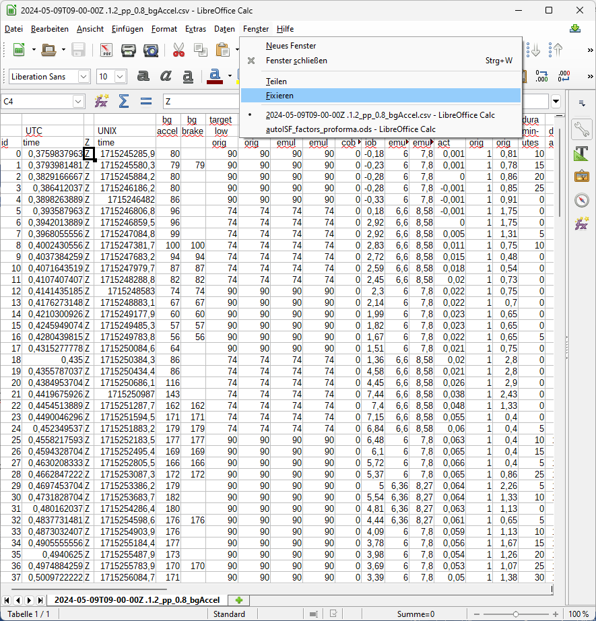

Still, the csv tables are overwhelming. You could proceed **in either of two** directions now:

1. Convert both (or all 3) csv files into one table in Excel or into Libre office calculator. Hide columns (and eventually also lines) that are of no particular interest for your analysis. Mark differences between noChange and (yourChanges) column data with color, add extra columns with additional calculations …

This route is good to compare quantitative impacts of autoISF categories in critical time points.

1. For the core data relevant to assessing your autoISF settings, there is an extra tool for convenient analysis - see the following section 10.3.3.3

That tool is quite a bit of work to set up. Decide for yourself whether you do it, or whether you rather work with extracting the csv table into Excel (A), and work freely from there.

* + - 1. Automated extraction from tabular results *(optional add-on)*

Decide for yourself, whether you rather go from the csv results table into .xls and produce what you want to see there for yourself.

*With a bit of extra set-up effort* (steps 1)-7), next 4 pages) *you can install an adjunct tool* that will always produce the nice graph for you as shown on the end of this section 10.3.3.3, in step 7).

Realizing that going through the following steps 1) – 7) is currently quite complicated, the developer is working at radically simplifying it in an update to be expected this summer (2024). If you feel a bit challenged, we suggest to just wait for this update, which will largely be embedded in *a newer version of* the autoISF_factors_proforma.ods, see next section.

1).**autoISF_factors_proforma.ods** is provided as an **extra tool** that you download from here:

[www.github/ga-zelle/APS-what-if/software](http://www.github/ga-zelle/APS-what-if/software)

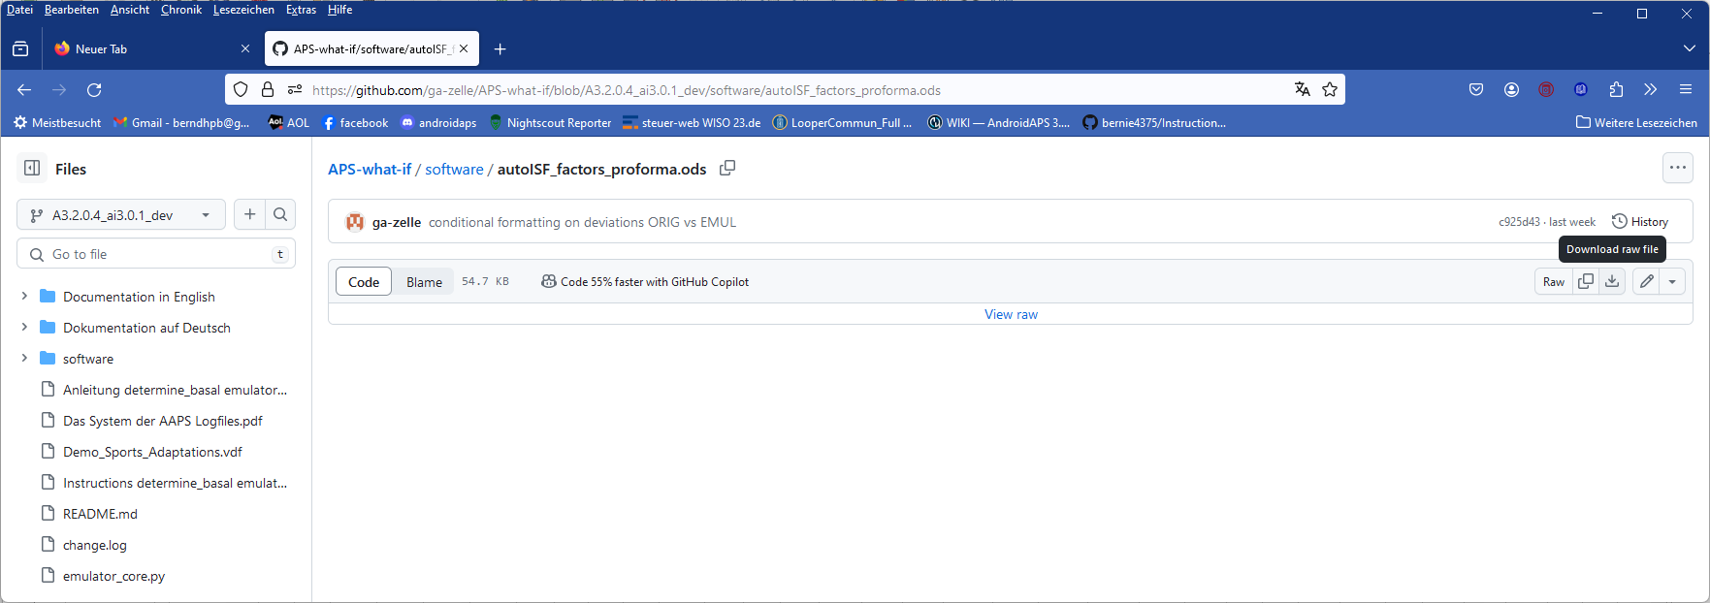

Put that file on your PC one level above the single files for all your studies:

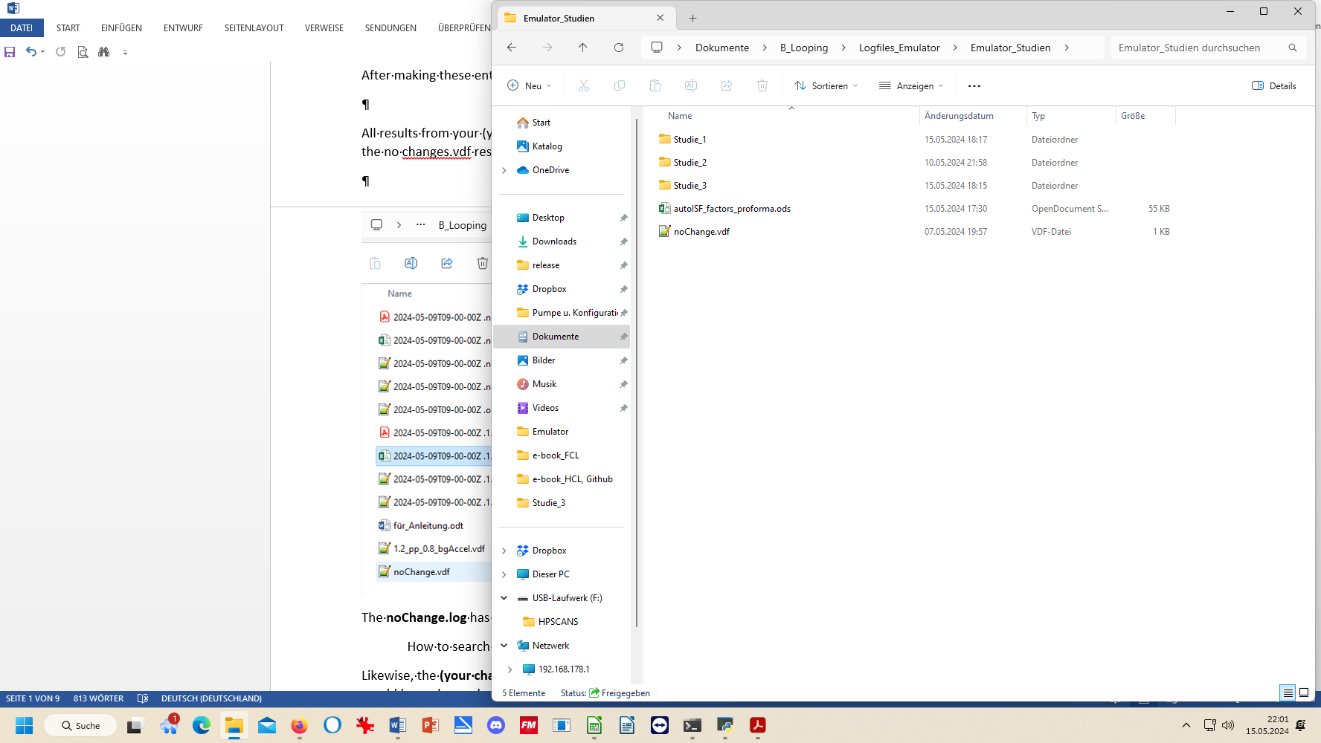

2).Now, if we want to use this tool on the two csv files of our Studie_3 file, we must proceed as follows (for *each* of the two .csv files, *separately*):

1. Click on the .csv file and open in Libre office calculator.
2. Make sure the time column is set to US_English:

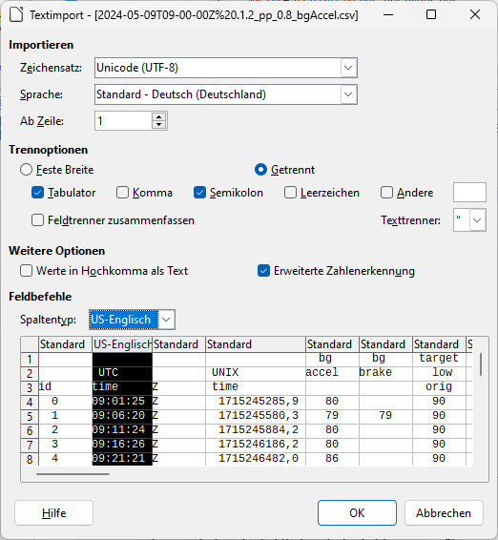

3).Now start, in Libre office calculator, the autoISF_factors_proforma.ods …

This turns the first 30-some lines of your csv table (left side) into a form in which important effects are highlighted in color, and formatting is improved:

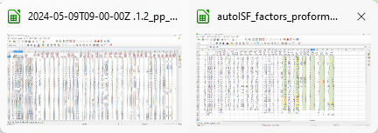

Now, you want this for the entire table.

4).In the autoISF_factors_proforma table, highlight 20 or more lines (not including the first or last), and mouse right hand/insert above … 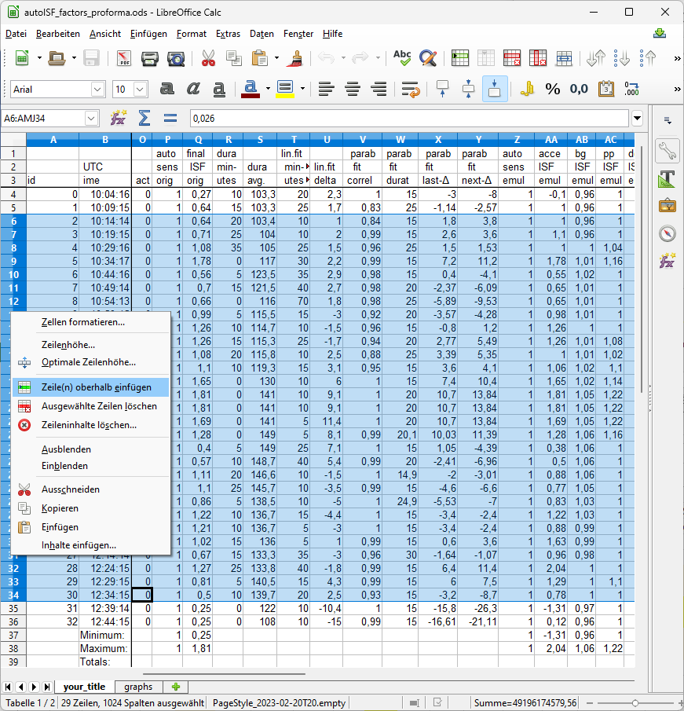

Do this as often as you need to create the number of lines that your emulated csv file comes with.

If you ended up with too many lines, erase the superfluous number (any four, in the example):

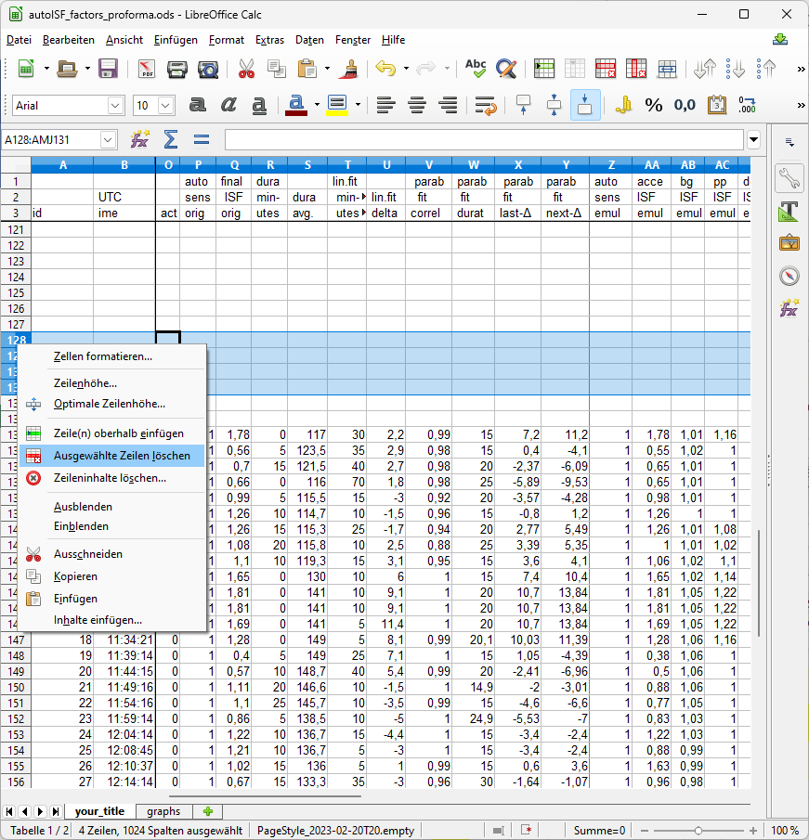

5).Then just copy it in, by selecting all data lines in the emulated csv, and pasting (paste special, values only) into box A4 of your “elonged” autoISF_factors_performa.ods.

6).The bottom tab “your_title” should be re-named by you, best with day of log you analyze, and your what-if parameters (so, the name of your csv file could be put in here)

**Now you have a table with optimized lay-out that incorporates key data from both your no change AND of your investigated changes.csv files.**

A similar table is available on the (i-)phone if you use the autoISF dev variant of iAPS or Trio (see section 11.3)

7).A super neat extra feature is already pre-programmed, which you can see if you click on the bottom **tab “graphs”.**

The top graph is the bg curve (the actually seen bg).

Note that for the what-if no bg development over the time range is available. (The noChange one is also given there).

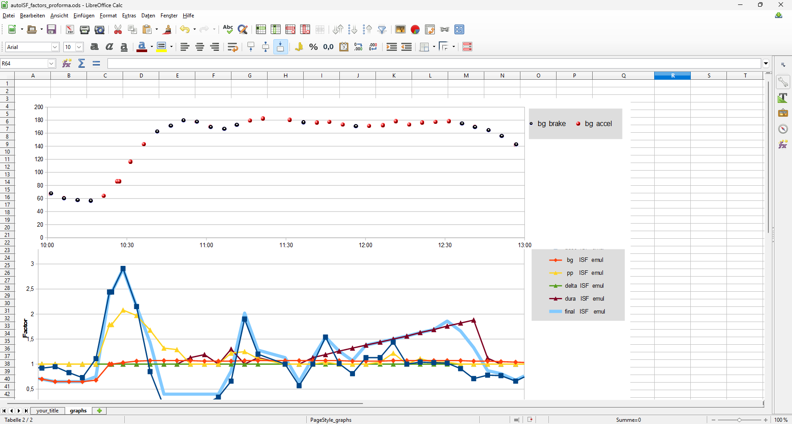

accel_ISF

< 1 brake_ISF

The bottom graph (do one for each, the noChange or the (yourChanges) case) shows the amplification factors coming from each autoISF category, and the overall resulting ISF amplification.

You probably have to widen the time scale (double click on the time axis, and type the desired time span (min and max UTC)(and spacing of data points, 00:30:00 or 00:15:00) into this box:

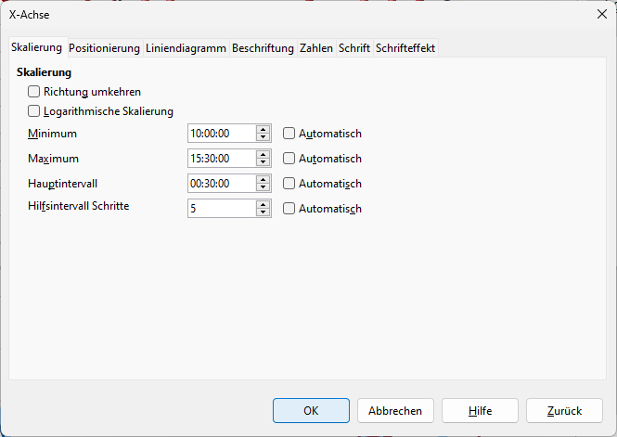

*In the given example above, the 2.5 hours were not enough yet to analyze this 10:30 UTC (12:30 AAPS) lunch; we need to look until bg is near target (hopefully before dinner starts).*

10.3.3.4 Chart coming with the emulator

In case you find the extra steps described in the preceding section “too much”: Also the emulator offers one chart (the pdf offered at the bottom of the screen as shown below the “10.3.3 Emulaton results” headline).

First look at the initial bg rise in the noChange.pdf chart (emulation results from your noChange.vdf run), and see how bgAccel_ISF and pp_ISF acted, or could have acted in improved ways.

Then look into in (yourChange).pdf to see potential effects (or what other change to try). (Actually, you probably will have to go into a detailed analysis of several lines and columns of the tables as discussed in sections 10.3.3.2 and 10.3.3.3).

Note that ideally we want FCL coverage of our entire “normal day” meal spectrum by **one** set of settings.

So, **not much is gained if you put a lot of effort in optimizing FCL settings for one meal**.

You will need iterations. Do such analysis for **two or three very different meals** that you wish the algorithm to automatically handle. See section 4.2/4.3 on how meals with very different carb loads might benefit or also suffer from aggressive or mild (category)_ISF_weights you could set.

The initial iob received might be limited by allowed SMB sizes, autoISFmax, or the (dynamic!) iobTH. You will have to look into the data table to find out about this (a quick orientation - notably regarding the light blue iobTH band, see next page - is also possible in the pdf result files you have in your project file (project file example “Studie 3” in 2nd chart under the 10.3.3. headline).

Only once you found OK weights for bgAccel- and pp_ISF_weights, does it make sense to go tune the dura_ISF_weight. 12:00 – 12:45 UTC in above graph, the resulting effective ISF is dominated by dura_ISF. Just judging from the picture, a stronger weight might be worth trying. However, we really need to see the insulinRequired calculation and the further development because impatience about bringing bg values down faster too often results in hypoglycemia later.

The **noChange.pdf** is a chart that shows along the time axis (down), from right to left:

* Red: the bg curve
* Yellow: the bg target (note that I do no manual “EatingSoonTT” but for bg rises over +10 mg/dl I have an Automation that sets low TT for a couple of minutes)
* Light blue corridor: Left edge is set iobTH, and bandwidth +30% (would be +20% at elevated TT)
* Dark blue line: iob (exceeding twice the iobTH, with temp. SMB shut-off
* Orange line: cob = 0 in FCL

iob

iobTH

**1.2 bgAccel …**

**noChange**

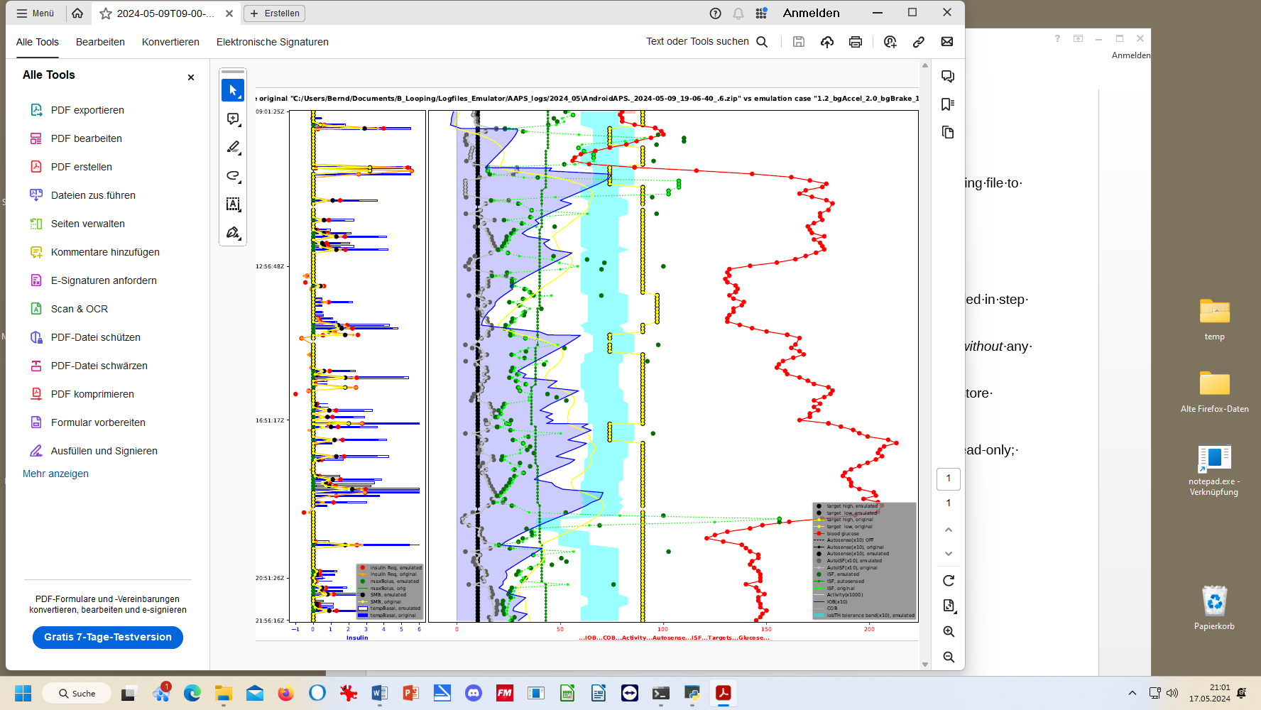



**Earlier stronger ISF** would lower the 1st bg rise. (earlier exceed iobTH *which also could be elevated a bit*).



* As bg did not convincingly come down enough, one could hypothesize that iobTH should be elevated. ((But, again, this would have to be confirmed also with other kinds of meals)).
* Thin yellow line: Insulin activity
* Green dotted line: ISF as would result from AAPS w/Autosens
* **Green scatter points**: autoISF ISF no Change (lighter points) or **what-if (darker** points)

Foreseeably, this is the strongest difference between our noChange (left) and 120% bgAcel_ISF_weight (right) in the picture below. (Note the red bg curve is *both times* the really seen bg, because the what-if case only looks at each single loop decision). The first ( **->** ) time the dark green dot is far to the right, this *would* get the bg down, we *would start to see* a ( **<-** ) bg lowering effect, shifting the red curve to the left

* Black line: Profile ISF
* Gray scatter points: ISF weakened (to the left of black line) or strengthened (to the right)

Regarding the other changed parameters: Stronger dura_ISF would suggest more insulin towards the end of plateaus; this should have helped in the 1st plateau (red curve, top right quadrant of the picture). However, same setting would have to work also on 2nd plateau; the chart cuts off there, so too early to see whether a hypo danger might result.

Effect from doubling the bgBrake_ISF effect are hard to evaluate. Better probably to look in .csv tables, or run a separate emulation for that change only.

Always check for 2 or 3 kinds of your meals whether the “new” parameter settings really are on average better. (See negative example in case study 8.2!)

Part of both above shown charts (left side of each, with blue peaks) was cut out.….

(unfinished / to be explained later) (Here:yourChange = 1.2_bgAccel_2.0_bgBrake_1.2_dura)

**noChange**

**1.2 bgAccel …**





10.3.3.5 delta

In case you want to analyze delta, short and long average deltas, see section 10.2.4.5

To analyze deltas in a “what-if” scenario really does not make much sense, because effects from each single change ripples through many subnsequent situations and it is impossible to preduict how glucose curve, and therefore also how deltas, would develop in the what-if case.

Final remark

Please share your experiences with the emulator in Discord / Full-Closed-Looping / HOW TO /_emulate-aaps, at: <https://discord.gg/n3tD5eXExC>

10.3.3.5 delta table from “what-if” run with (yourChange).vdf

In case you want to analyze delta, short and long average deltas, see section 10.2.4.5

To analyze deltas in a “what-if” scenario really does not make much sense, because effects from each single change ripples through many subsequent situations, and it is impossible to predict how glucose curve, and therefore also how deltas, would develop in the what-if case.